**Nikunj Verma**

**Roll Number: 197931**

create table weather(

RainType varchar(30),

Region varchar(30),

Season varchar(30),

rain_record int

);

insert into weather values('monsoon','north','summer',10);

insert into weather values('monsoon','north','winter',20);

insert into weather values('monsoon','south','summer',20);

insert into weather values('monsoon','south','winter',50);

insert into weather values('monsoon','west','winter',20);

insert into weather values('monsoon','east','summer',10);

insert into weather values('monsoon','east','winter',30);

insert into weather values('cyclone','north','summer',40);

insert into weather values('cyclone','north','winter',60);

insert into weather values('cyclone','south','summer',70);

insert into weather values('cyclone','south','winter',80);

insert into weather values('cyclone','west','winter',80);

insert into weather values('cyclone','east','summer',60);

insert into weather values('cyclone','east','winter',90);

**--Q(b)(i)Using an OLAP operator other than ROLLUP, write an SQL query to compute the average rainfall recorded for prefix list of attributes (Season ,region).**

**ANS:**

select Season,Region,avg(rain_record)

from weather

GROUP BY grouping sets((Season,Region),());

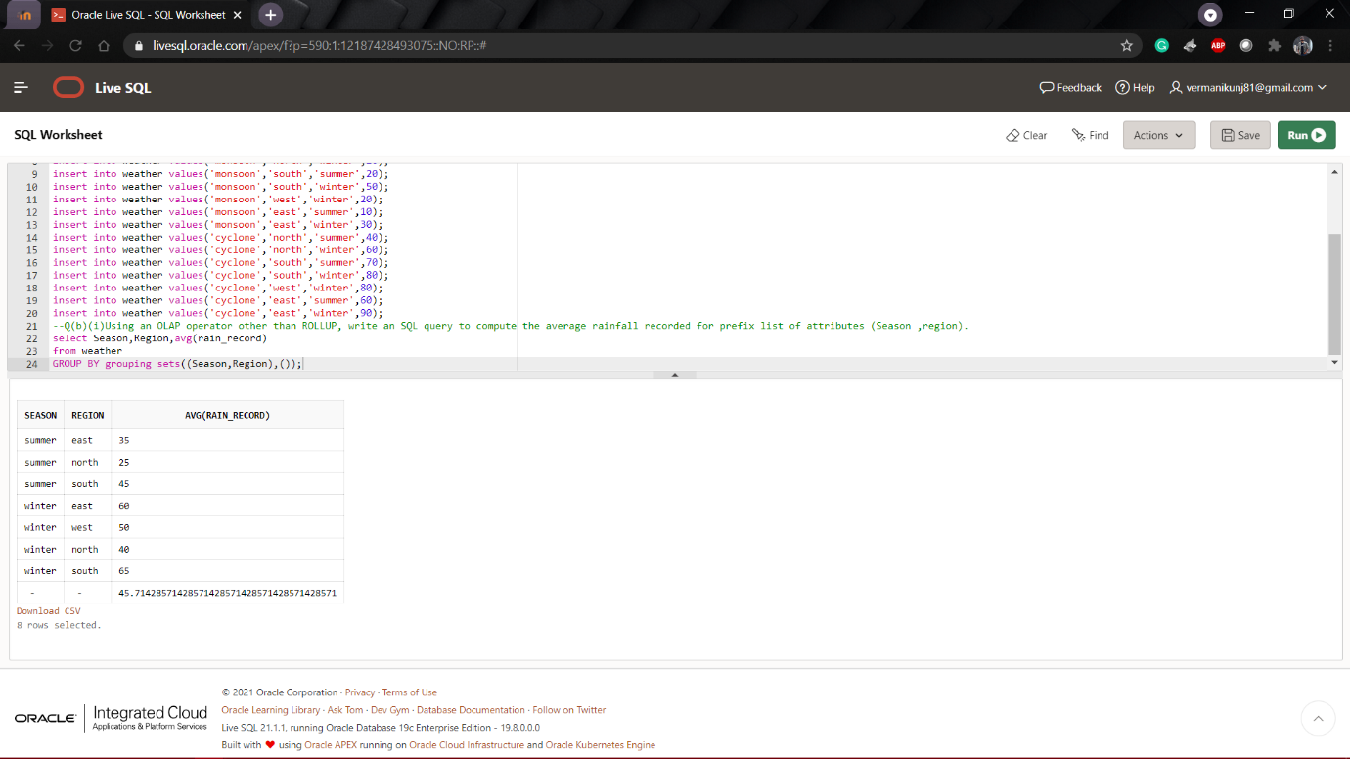

**--Q(b)ii. Using an OLAP operator write an SQL Query to find total rain recorded with subtotals for every combination of attribute list(region, raintype).**

**ANS:**

select Region,rain_record,sum(rain_record)

from weather

GROUP BY cube(Region,rain_record);

